NIP Project — Submission Template

Section 1 — Your Details
Full Name | MEERA B
Email ID (registered on NIP) | meeragbs123@gmail.com
Phone Number | 9345549104
College Name | V.S.B.ENGINEERING COLLEGE,KARUR
Course (e.g. IT, CS) | CSE
State | TAMILNADU
Project Chosen (Vehicle Service OR Movie Ticket Booking) | MOVIE TICKET BOOKING
Pega Application Name (e.g. NIP-VehicleService-YourName) | NIP-Movie Ticket-Meera
Case Type Name (exact) | Movie Ticket Request
Pega Instance URL | https://vpr84hdy.pegacea.net/prweb/app/fraud-investigation/
Operator Name (created in Pega with your full name) | Meera

Section 2B — Movie Ticket Booking Management Application

US-001 — Submit Movie Ticket Request
What is expected:
Case created, customer submits Movie Name, Show Date, Show Time, Number of Tickets. Validation applied.
Screenshot — paste your screenshot below this line:
[ Paste screenshot here - follow the screenshot rules above ]

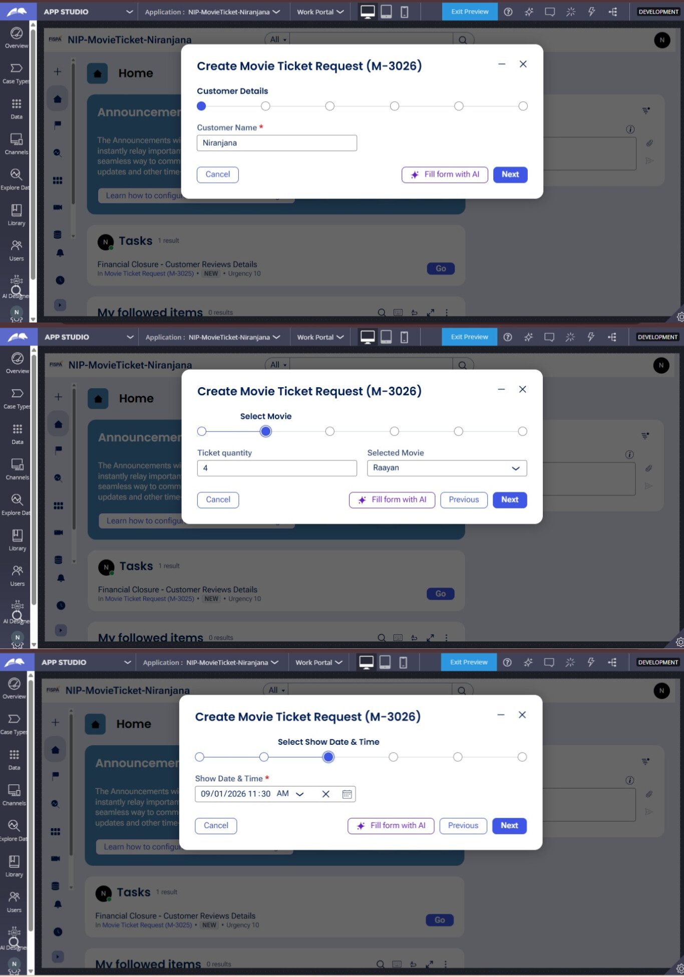

What I built for this (1–2 lines in your own words):
I created a Movie Ticket Request form where the customer can enter their details, select a movie, choose the show date and time, and enter the number of tickets. Required field validation is applied before proceeding.

US-002 — Check Show Availability
What is expected:
Availability stage. Seat Availability Status and Available Seats Count captured. Booking proceeds only if available.
Screenshot — paste your screenshot below this line:
[ Paste screenshot here - follow the screenshot rules above ]

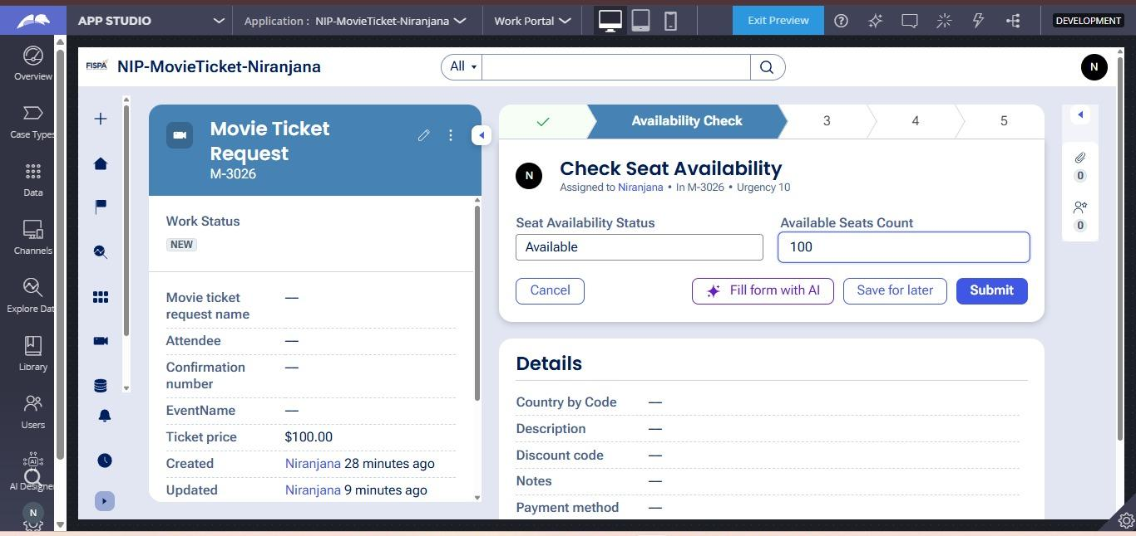

What I built for this (1–2 lines in your own words):
I created the Availability Check stage to capture the Seat Availability Status and Available Seats Count. The booking proceeds only when the seat availability status is available.

US-003 — Calculate Booking Cost
What is expected:
Total Cost calculated automatically from Ticket Price and Number of Tickets using a business rule.
Screenshot — paste your screenshot below this line:
[ Paste screenshot here - follow the screenshot rules above ]

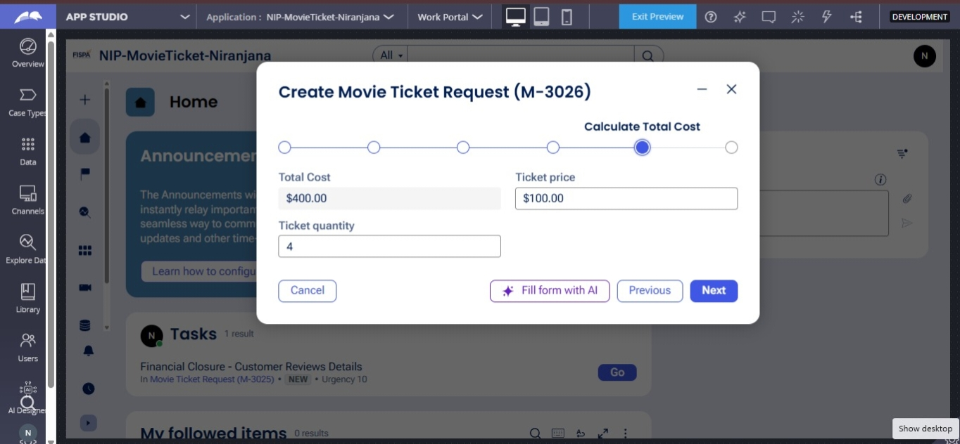

What I built for this (1–2 lines in your own words):
I configured a business rule to automatically calculate the Total Cost based on the Ticket Price and Ticket Quantity. For example, 4 tickets at $100 each gives a Total Cost of $400.

US-004 — Confirm Booking Request
What is expected:
Approval stage assigned to Customer. Booking Status captured. Flow branches on confirm/cancel.
Screenshot — paste your screenshot below this line:
[ Paste screenshot here - follow the screenshot rules above ]

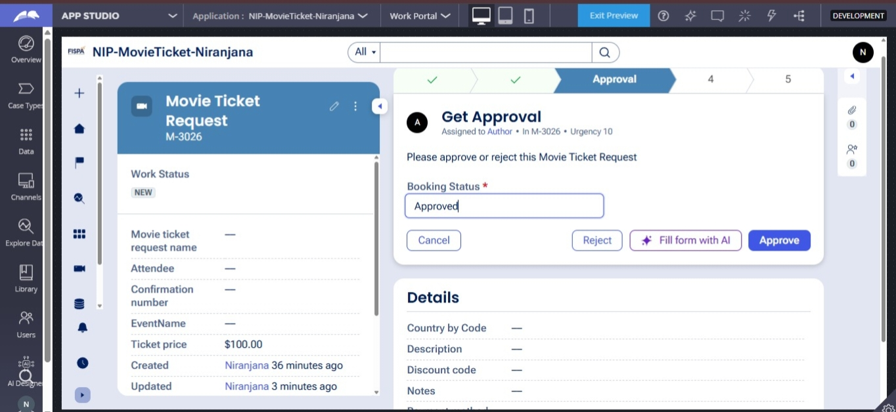

What I built for this (1–2 lines in your own words):
I configured an Approval stage to capture the Booking Status and allow the user to approve or reject the Movie Ticket Request. The case flow branches based on the confirmation or cancellation decision.

US-005 — Maintain Movie and Show Data
What is expected:
Reusable Movie and Show data objects created with Movie Name, Genre, Show Date, Show Time, Seat Capacity — linked to case.
Screenshot — paste your screenshot below this line:
[ Paste screenshot here - follow the screenshot rules above ]

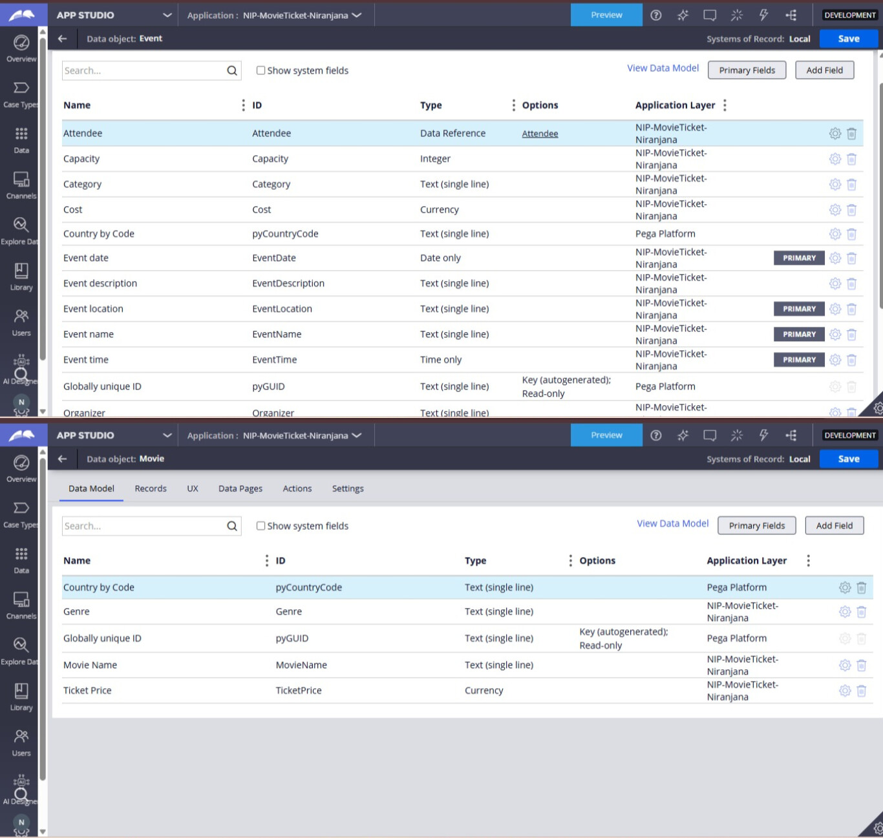

What I built for this (1–2 lines in your own words):
I created reusable Movie and Event data objects to store Movie Name, Genre, Ticket Price, Event Date, Event Time, and Seat Capacity. These data objects are used in the Movie Ticket Request case to manage movie and show information.

US-006 — Review Booking Details
What is expected:
Confirmation screen shows Movie Name, Show Timing, Number of Tickets and Total Cost clearly.
Screenshot — paste your screenshot below this line:
[ Paste screenshot here - follow the screenshot rules above ]

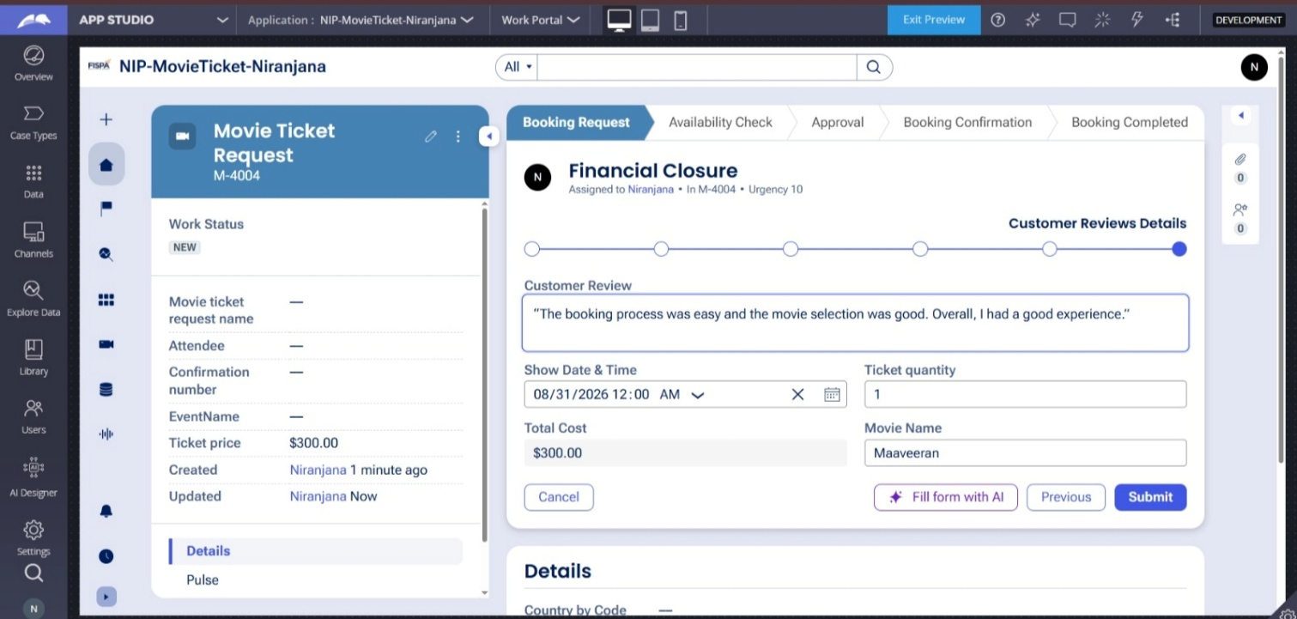

What I built for this (1–2 lines in your own words):
I created a booking review screen that clearly displays the Movie Name, Show Date and Time, Number of Tickets, and Total Cost before the booking is confirmed.

US-007 — Process Ticket Booking
What is expected:
Booking Execution stage. Seat Numbers, Ticket ID and Booking Confirmation Status maintained.
Screenshot — paste your screenshot below this line:
[ Paste screenshot here - follow the screenshot rules above ]

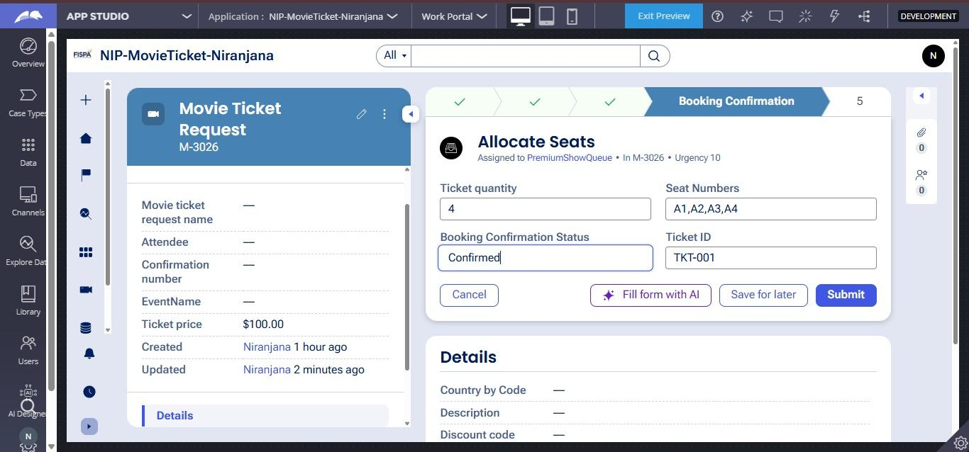

What I built for this (1–2 lines in your own words):
I configured the Booking Confirmation stage to allocate and maintain Seat Numbers, generate a Ticket ID, and capture the Booking Confirmation Status. The booking is confirmed after the ticket details are successfully processed.

US-008 — Notify Booking Confirmation
What is expected:
Correspondence rule triggered on case resolution. Email includes movie, show, seat and cost details.
Screenshot — paste your screenshot below this line:
[ Paste screenshot here - follow the screenshot rules above ]

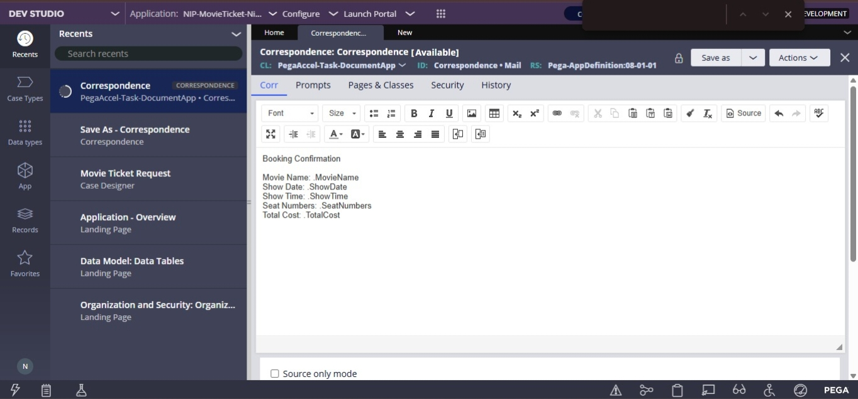

What I built for this (1–2 lines in your own words):
I configured a correspondence rule to send a booking confirmation email containing the Movie Name, Show Date, Show Time, Seat Numbers, and Total Cost when the booking is completed.

US-009 — Define Booking SLA
What is expected:
SLA configured on the case type. Goal: 1 day. Deadline: 2 days. Priority increases on breach.
Screenshot — paste your screenshot below this line:
[ Paste screenshot here - follow the screenshot rules above ]

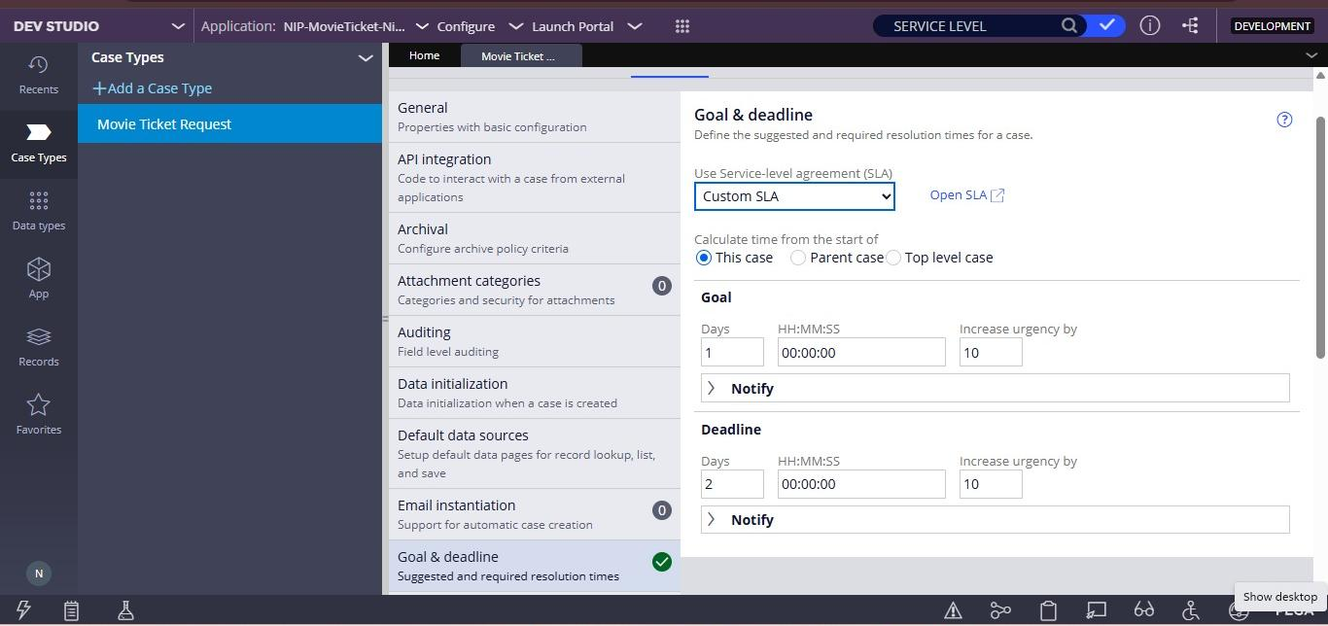

What I built for this (1–2 lines in your own words):
I configured a Custom SLA for the Movie Ticket Request case with a Goal of 1 day and a Deadline of 2 days. The case urgency increases by 10 when the SLA goal or deadline is reached.

US-010 — Route by Show Type
What is expected:
Routing rule or Decision Table routes to PremiumShowQueue or StandardShowQueue based on Show Type property.
Screenshot — paste your screenshot below this line:
[ Paste screenshot here - follow the screenshot rules above ]

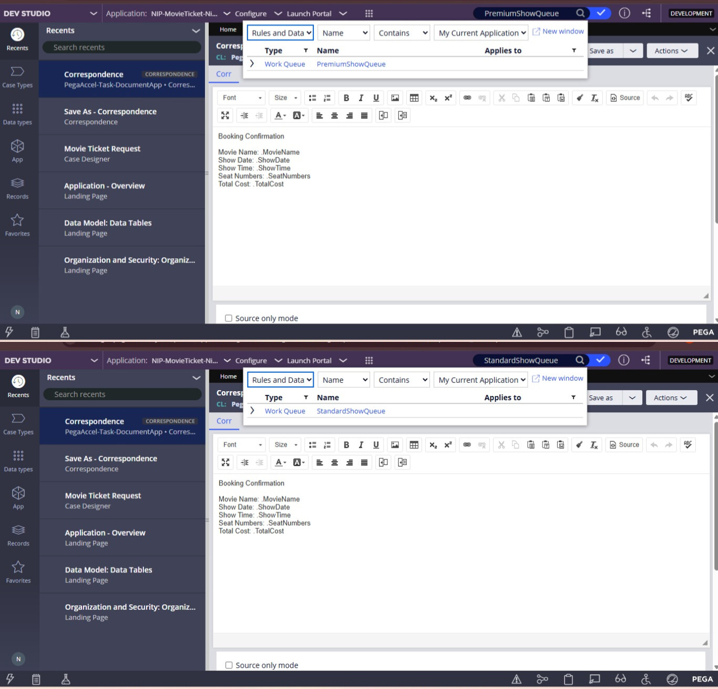

What I built for this (1–2 lines in your own words):
Created PremiumShowQueue and StandardShowQueue work queues to support routing based on the selected Show Type.

Section 3 — About Your Application
Q1. List your stages in the order they appear in your case lifecycle.
Stage names in order, separated by commas.
Booking Request, Availability Check, Approval, Booking Confirmation, Booking Completed.

Q2. Name the data object(s) you created and the properties inside them.
Data object name and its properties.
I created two data objects: Movie and Event. The Movie object contains Movie Name and Genre. The Event object contains Movie Name, Show Date, Show Time, and Seat Capacity.

Q3. What is the exact name and type of the rule you used to calculate Total Cost?
Provide:
• Rule Name
• Rule Type
• Properties used in the calculation
• Formula used
Rule Name: CalculateTotalCost
Rule Type: Data Transform
Properties used: Ticket Price and Ticket Quantity
Formula: Total Cost = Ticket Price × Ticket Quantity

Section 4 — Your Understanding
Short, honest and specific answers score well.

Q4. What did Blueprint generate for you, and what did you add or change yourself afterwards?
Be specific about what was already there and what you built or modified on top.
Blueprint gave me the basic structure of the Movie Ticket Booking application, including the case and initial fields. After that, I added and configured the required stages, Movie and Show data, availability check, booking cost, approval, booking execution, SLA, and work queue routing based on the project requirements.

Q5. Was there anything Blueprint created that you had to correct or configure further? Describe one example.
A real example from your own work.
Yes One example was the Operator setup. The Organization, Division, and Unit details were not accepted initially, so I checked the organizational structure and configured the correct values before saving the Operator.

Q6. Explain your case flow from creation to resolution, in order.
What happens first, who does what, when the case closes.
First, the customer creates the Movie Ticket Request with the movie, show date, show time, and number of tickets. Next, availability is checked. The booking cost is calculated and the customer reviews and confirms the booking. After confirmation, the booking execution is completed with seat numbers and ticket ID, and the case is finally resolved.

Q7. Pick two design choices you made in your application and explain why you made them.
For each design choice, provide:
• What you implemented
• Why you chose that approach
• What benefit it provides to the application
1. Customer Review before approval: I added a review step so the customer can check the movie, show timing, number of tickets, and total cost before confirming. This helps avoid mistakes before booking.
2. Premium and Standard work queues: I used separate queues for premium and standard shows. This helps route bookings to the right team automatically and makes the booking process easier to manage.

Q8. What was the hardest part, and how exactly did you fix it?
Specific and honest. A real challenge scores much better than a generic answer.
The hardest part was configuring the Total Cost calculation because the Ticket Price was showing as 0.00. I checked the Movie data and the case fields, then configured the Ticket Price and Total Cost fields to use the ticket quantity for the calculation.

Q9. If the approval step was only needed when Total Cost is above a certain amount, what would you change in your application?
Explain what you would change and where. You do not need to build this.
I would add a condition before the Approval stage to check the Total Cost. If the Total Cost is above the specified amount, the case would go to the Customer approval step. If it is below the amount, it would skip approval and continue to the booking process.

Q10. List three exact rule names from your application that you personally created or modified.
Include the rule name and rule type for each one (for example: CalculateTotalCost - Declare Expression).
• CalculateTotalCost — Data Transform
• CheckSeatAvailability — Flow Action
• CustomerReviewsDetails — Flow Action
Q11. List all personas used in your application.
List the persona names exactly as they appear in your application.
Attendee
Ticketing Manager
Q12. List all work queues used in your application and explain when each one is used.
For each work queue, provide its exact name and the condition or type of work routed to it.
PremiumShowQueue – Used for premium or special movie shows.
StandardShowQueue – Used for all other standard movie shows.

